Press control and click on a topic to jump straight to that section.

Introduction 1

Logging in, initial display, logging out 2

The ‘My Probation’ tab 3

‘Personal details’ section 3

‘Own probation’ section 3

‘Staff probation tasks’ section 3

My Staff Probation Tasks 4

‘View Probation’ button 4

‘Edit Probation’ button 4

‘Reassign Manager’ button 7

The ‘My Staff’ tab 7

The ‘Help’ tab 7

My actions 7

Manager guide 8

Contact us 8

Logout 8

Language Preference 8

Email notifications 8

Printing 9

HR Users 10

The ‘Local HR’ tab 10

Introduction

The eProbation system provides online support for the probationary process that applies to new recruits and newly-promoted employees.

The employee’s electronic probation is reviewed and updated by the line manager at quarterly intervals during the probationary term. The last review is performed by local HR, and constitutes a sign-off on the probation process. The sign-off decision made by the local HR manager is based on the line manager’s assessments.

There are three classes of user: line manager, local HR manager, and administrator (National Shared Services Office – NSSO). This document details the operation of the eProbation application from the viewpoint of the employee’s line manager.

Logging in, initial display, logging out

You can access the eProbation system through a web browser, by going to the ‘Access to our systems’ heading on [www.nsso.gov.ie](http://www.nsso.gov.ie). You need to log into eProbation using your NSSO username and password. These are the same details you use for the HR Management System (HRMS), where you apply for annual leave.

Once you have entered your details, click on Login. If you forget your password you can get a new one, see our First Time Sign-In and Password Recovery Guide.

The initial screen shows your name, organisation, grade, manager’s name, and email address in the top banner. Below this is the status of your own probation, if applicable. At the bottom is a list of the probation tasks awaiting your input.

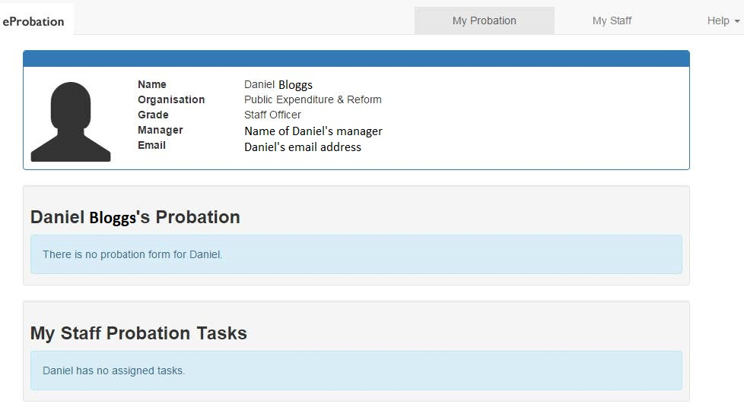

There is a menu bar across the top showing three tabs:

1. The My Probation tab is activated by default when you log in to the system.
2. The My Staff tab shows the members of staff who report to you.
3. The Help tab displays a menu with options allowing you to read the Line Manager guide to the eProbation system, view a history of your activities within the application, and set your language preference. There is also an option allowing you to exit the system.

To log out simply select the ‘Logout’ option from the Help tab on the menu bar.

The ‘My Probation’ tab

When you log in to eProbation, the ‘My Probation’ tab is selected by default. It contains three sections:

* Personal details.
* Details of your own probation if you are on probation.
* A list of probation forms for your staff that require assessment.

‘Personal details’ section

The personal details section shows your name, department, grade, manager, and email address.

‘Own probation’ section

The ‘own probation’ section shows a ‘no probation form’ message if you are not on probation. If you **are** on probation the ‘own probation’ section shows the status of your probation. You cannot edit your own form, so there is no ‘edit probation’ facility.

‘Staff probation tasks’ section

The ‘staff probation tasks’ section shows a ‘no assigned tasks’ message if you have no staff on probation, or if there are no assessments due for completion. If you have staff on probation **and** if there are assessments to be completed, the probation forms will be listed in this section.

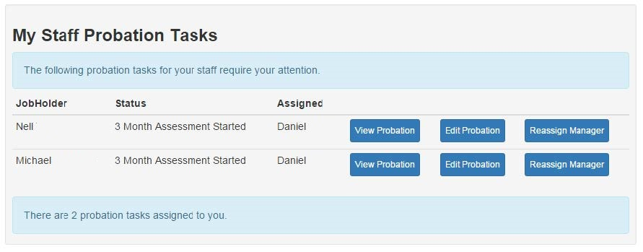

* You can edit a form by pressing the ‘Edit Probation’ button.
* You can view a read-only version by pressing the ‘View Probation’ button.
* You can reassign a form to another manager by pressing the ‘Reassign Manager’ button. This reassignment is temporary - it applies only to the probation form’s current assessment stage.

My Staff Probation Tasks

‘View Probation’ button

To see the form history, you can press the ‘View Probation’ button beside the staff member’s name.

* Press the ‘3 Month Assessment’ button to see the form as it stood at the end of the 3 month assessment period.
* Press the ‘6 Month Assessment’ button to see the form as it stood at the end of the 6 month assessment period, also showing the earlier 3 month assessment.

Sections of the form that are hidden can be displayed by pressing the ‘Show/Hide’ button, and sections that are visible can be hidden by pressing the same button. A red bar across the bottom of the screen notes that the form cannot be edited. The form can be browsed using the vertical scrollbar to the right of the form.

‘Edit Probation’ button

To update the form you can press the ‘Edit Probation’ button. Each probation form consists of three assessments completed by the line manager (after 3, 6, and 9 months of probation) and a sign-off section completed by the local HR manager.

The three assessment sections that the line manager completes are broadly similar, with the same questions being asked at each stage. Only the 9 month assessment section differs, as the ‘final’ nature of the third assessment is emphasised.

The assessment section is a set of standard questions involving performance, sick leave, attendance and punctuality, and general conduct. The answers are mostly a straightforward ‘yes’ or ‘no’, and can be selected from the drop-down list beside the answer box. The drop-down list that appears in answer to the question regarding compliance with flexi-time requirements also features a ‘not applicable’ response.

Some fields require data to be entered by the line manager. These questions relate to sick leave absences, and time-keeping infringements. The sick leave data is pre-populated from the HR records. As the tooltip explains, however, these values may not reflect the full amount of sick leave taken.

Screenshot of a blank eProbation form for a 3 month assessment. 

Under Performance it lists the following questions: 1. Work performed accurately and effectively? 2. Work is of good quality, well executed, and meets deadlines?, 3. Works well with colleagues and is part of the team? and 4. Demonstrates the required ability to performa all duties of the role?

Under Sick Leave it lists the following questions: 1. Has the jobholder complied with all sick leave requirements? 2. Number of certified sick days - HR records show X days. and 3. Number of uncertified sick days - HR records show X days.


The pre-populated sick leave figures are cumulative: they reflect the number of sick days taken since the start of the employee’s probation, not the start of the 3 month period being assessed. These figures may be overwritten if needed.

The ‘number of infringements’ field accepts whole numbers only. If fractions are entered, they will be deemed invalid when the probation form is submitted.

The final three fields in each section are critical. You summarise your assessment by giving an opinion on the employee’s performance during the period under review.

Screenshot of a blank eProbation form for a 3 month assessment. 

Under Attendance and Punctuality it lists the following questions: 1. Has the Jobholder complied with Annual Leave regulations? 2. Has the Jobholder complied with Flexi-time requirements? and 3. Number of infringements (mornings and evenings).

Under General Conduct it asks: Has the Jobholder conduct been satisfactory in all regards?

Under Assessment it asks the following questions: 1. Have you discussed this assessment with the staff member? 2. I can confirm that the jobholder's performance is and 3. Comments.

Below this are the Save Draft button (left) and the Submit button (right).

Probation policy requires that you discuss the assessment with the staff member on probation, prior to completing the relevant assessment section of the form. You should indicate you have complied with this requirement by selecting ‘Yes’ from the drop-down list beside ‘Have you discussed this assessment with the staff member?’.

The drop-down list for the employee’s performance contains two possibilities: satisfactory or unsatisfactory. Note however, that selecting ‘Unsatisfactory and needs to show improvement’ flags the probation form for the attention of local HR.

The comments box, as the tooltip indicates, should be updated with additional notes concerning the employee’s performance during the assessment period under review. In particular, it is a good place to record reasons for negative answers to the assessment questions. The comments box expands as you type - there is no limit to the amount of text you may enter.

While completing the assessment, you can press the ‘Save Draft’ button to save a copy of the probation form for later editing. Saving a draft copy has no effect on the status of the form or the overall state of the probation process for the employee. You may continue editing the form immediately after saving a draft, or may return to it later. All updates made to the form when the draft was saved are preserved.

Press the ‘Submit’ button to save the form and move the probation process forward to the next stage. When the ‘Submit’ button is pressed, the system checks that all the assessment questions have been given answers. Invalid responses are flagged.

Correcting validation errors allows you to submit the form. Once a probation form has been submitted, your ‘My Probation’ screen is redisplayed, but now the list of staff probation tasks has been reduced by one. In addition, an email notification is automatically sent to the employee informing them that you have completed their 3/6/9 month probation assessment and that they may now view it on the system. If you have given an ‘unsatisfactory’ assessment, an email stating this would be generated and sent to local HR.

‘Reassign Manager’ button

Pressing the ‘Reassign Manager’ button permits you to temporarily assign the form to another manager. Once the assessment has been completed by the new manager, the form will be reassigned to the original line manager afterwards.

You will be asked to enter the full name or NSSO user ID of the temporary manager. Press the ‘Choose’ button beside the correct manager. Your initial (My Probation) screen is then redisplayed with a message stating that the employee’s form has been reassigned to that manager, and the section listing the probation forms for your staff no longer includes the form for that employee.

The ‘My Staff’ tab

Selecting the ‘My Staff’ tab on the menu bar allows you to see a list of your staff members, whether they are on probation or not. For those staff members who are on probation, the status of their respective probation process is displayed.

Pressing the ‘View Probation’ button associated with a staff member’s probation form shows a history of the form at the various stages of its probation process to date. The fact that the form cannot be edited is indicated by a red bar across the bottom of the display showing the message ‘You do not have access to these buttons’.

The ‘Help’ tab

The Help tab at the right-hand end of the menu bar contains options for displaying your activities within the eProbation system, viewing the Line Manager’s guide to the system, contacting the NSSO through our website, and logging out of the system. You can also set your preferred language for viewing the eProbation system.

My actions

Press ‘My actions’ to see a summary of all activities you have performed on the system. Clicking into the ‘View Form (Status)’ column will show the historic record of forms you have submitted. None of the fields are editable – the red bar across the screen of the display confirms this – and sections of the form may be hidden or displayed by pressing the ‘Show/Hide’ buttons on the assessment section headings.

Manager guide

Selecting the ‘Manager guide’ option displays the eProbation Line Manager guide. The document opens in a separate browser window.

Contact us

The NSSO provides first-level support for the eProbation system. Selecting the ‘Contact us’ option displays our website in a separate browser window.

Logout

Selecting the ‘Logout’ option exits the eProbation system. The original login screen is displayed.

Language Preference

By default, all headings and labels in the eProbation system are shown in English. To change the language to Irish, select ‘Irish’ from the language drop-down list and press the ‘Go’ button. This results in the translation of the various labels and headings on the screen.

Email notifications

The eProbation system is dependent on automatic and manual interventions. The initiation of a probation process is automatic, and is triggered by updates to the HR records.

The scheduling of the 3 month, 6 month, and 9 month assessment stages is also automatic controlled, as is the timing of the HR sign-off.

Nevertheless, the system cannot work without the manual assessments of line managers and the manual sign-off of local HR. To facilitate this the system sends a email notifications at relevant points in the process.

**eProbation kick-off**

Employee notified: Yes

Manager notified: Yes

Local HR notified: Yes

**3 month assessment**

Employee notified: Yes, when completed.

Manager notified: Yes, when due and again when completed.

Local HR notified: Only for unsatisfactory ratings.

**6 month assessment**

Employee notified: Yes, when completed.

Manager notified: Yes, when due and again when completed.

Local HR notified: Only for unsatisfactory ratings.

**9 month assessment**

Employee notified: Yes, when completed.

Manager notified: Yes, when due and again when completed.

Local HR notified: Only for unsatisfactory ratings.

**HR sign-off stage**

Employee notified: Yes, when completed.

Manager notified: Yes, when completed.

Local HR notified: Yes, when due and again when completed.

If assessments or sign-offs are not completed in a timely manner, the eProbation system will send automated reminder emails to the line manager or local HR. The first is sent 10 days after the due date; the second 20 days after the due date.

Printing

Any screen in the eProbation system may be printed using the Ctrl + P keyboard combination.

**Please note:** when printing a probation form, only the visible parts of the form are printed. If you wish to print hidden sections, then first display those sections using the ‘Show/Hide’ buttons on the section headings.

HR Users

Log into eProbation as usual. There is a menu bar across the top with three tabs:

* The My Probation tab is activated by default when you log in to the system.
* The My Staff tab shows the members of staff who report to you.
* The Help tab displays a menu with options allowing you to read the Line Manager guide and Local HR guide to the eProbation system, view a history of your activities within the application, and set your language preference. There is also an option allowing you to exit the system.

These three tabs are available to all users of the eProbation system. An additional tab is available to local HR users.

* The Local HR tab displays a menu with options that allow a local HR user to perform probation-related functions for staff members within the department.

To log out simply select the ‘Logout’ option from the Help tab on the menu bar.

The ‘Local HR’ tab

The ‘Local HR’ tab displays a menu with options allowing the local HR user to search for an employee, sign-off probation forms, and list all staff members on probation.

The results and effects of these options are confined to staff members within the local HR user’s own department. A local HR user in the Department of Finance, for example, cannot search for an employee in the Department of Social Protection.

**HR Users - Search for a user**

Selection of this option displays the following ‘Search for a user’ dialogue box:

Screenshot of the 'search for a user' function available to HR staff. A search field is shown immediately below the phrase search for a user. Beneath this are headings for User, Name, Grade and Department. On the bottom right there is a 'Close' button.

You may search for an employee using the employee’s full name, HRMS username, or PPS number. In either case, pressing the ‘Choose’ button displays details for that employee and their probation status, if any.

**HR Users - Local HR tasks**

The ‘Local HR tasks’ option displays a list of staff whose probation forms require sign-off. Only forms for your own department are shown.

Please take note of the ‘tick mark’ and ‘question mark’ icons to the left of the ‘Edit Probation Form’ buttons. A tick indicates that all the probation periods were assessed as ‘Satisfactory’ by the line manager. A question mark indicates that at least one of the assessment periods was assessed as being unsatisfactory.

Screenshot of the local HR tasks section, with Department of Public Expenditure and Reform shown as the relevant department. 

There is an automated message "The following probation forms require Local HR sign-off". Beneath this there are headings for JobHolder, Status and Assigned. 

These fields have been populated with dummy information. On the right of the Assigned field is a 'tick' icon or a 'question mark' icon. On the right of these icons is a blue button marked 'Edit Probation Form'.

To sign-off on a probation form, press the ‘Edit Probation Form’ button. This displays the entire form, but only the ‘HR Sign Off Probation’ section at the end can be edited. The response to the ‘Confirmation of Appointment’ question is a simple ‘yes’ or ‘no’, and may be selected from the drop- down list.

Having decided on a response to the ‘Confirmation of Appointment’ question, you may save a draft copy of the form for further consideration by pressing the ‘Save Draft’ button, or conclude the probationary process by pressing the ‘Submit’ button.

* Saving a draft does not change the status of the form - it still appears in the list of Local HR Tasks.
* Submission of the form marks the end of the probation process on the eProbation system - the form is removed from the list of Local HR Tasks.

**HR Users - Staff on Probation**

The ‘Staff on Probation’ option allows you to see a list of all the staff members within the department who are currently on probation, together with the probation stage.

For each staff member on probation, a ‘View User’ button displays a screen showing details of the employee with further options to view or, when appropriate, edit the employee’s probation form. The entries awaiting local HR sign-off on their probation form also show an ‘Edit Probation Form’ button.

The list of staff members on probation features the usual column of ‘tick marks’ and ‘question marks’ indicating whether an ‘unsatisfactory’ assessment was made at any point during the employee’s probationary period. These unsatisfactory ratings may merit further attention, but can be difficult to discern in a long list. Press the ‘View unsatisfactory probations’ button at the top right of the list to show only staff members whose probation forms were assessed as ‘unsatisfactory’.

The format of the unsatisfactory probations list is identical to that of the original list, and the same buttons allowing viewing of user details or editing the probation form (when appropriate) are available. The full list of staff members on probation may be redisplayed by pressing the ‘View all probations’ button at the top right side of the list.

* In all cases, the ‘View User’ display will include a ‘View Probation’ button.
* If the staff member’s probation form is awaiting local HR sign-off then an ‘Edit Probation’ button will also be displayed. This allows you to perform the sign-off.
* If you happen to be the staff member’s line manager too, and the probation form is assigned to you as line manager, then an ‘Edit Probation’ button will be displayed regardless of the stage of the staff member’s probation.