FMS User Guide

Submitting Financial Management Service (FMS) information through a Position Change, Hire or Internal Transfer Mass Instruction Request.

Position Change MIR
NSSO Logo

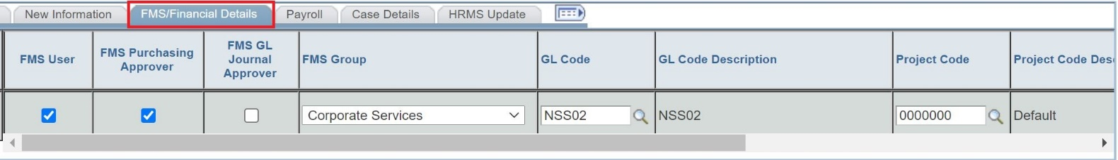

- The Position Change MIR will be the primary location to change FMS/Financial Details.

- FMS/Financial details can be submitted as the only change in the MIR. There is no obligation to change position information in the same MIR.

- With the Position Change, the details in the ‘FMS/Financial Details’ tab is the current real-time information that the officer has in their position.

- All officers will have a GL Code and a Project Code in their position after the FMS Cutover has been completed.

- The ‘GL Code’ and ‘Project Code’ fields are mandatory. There must be a value present in these fields for the MIR to be submitted.

- If the ‘FMS User’ box is ticked, then the ‘FMS Group’ dropdown box become mandatory and a value must be selected.

- The ‘FMS Purchasing Approver’ and ‘FMS GL Approver’ tick boxes remain optional.

Hire/Internal Transfer MIR

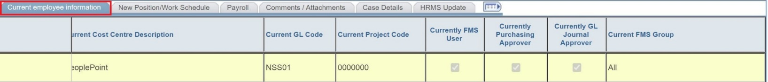

- For a Hire/Internal Transfer, the current GL Code, Project Code and FMS User Information can be found in the Current Employee Information tab (above).
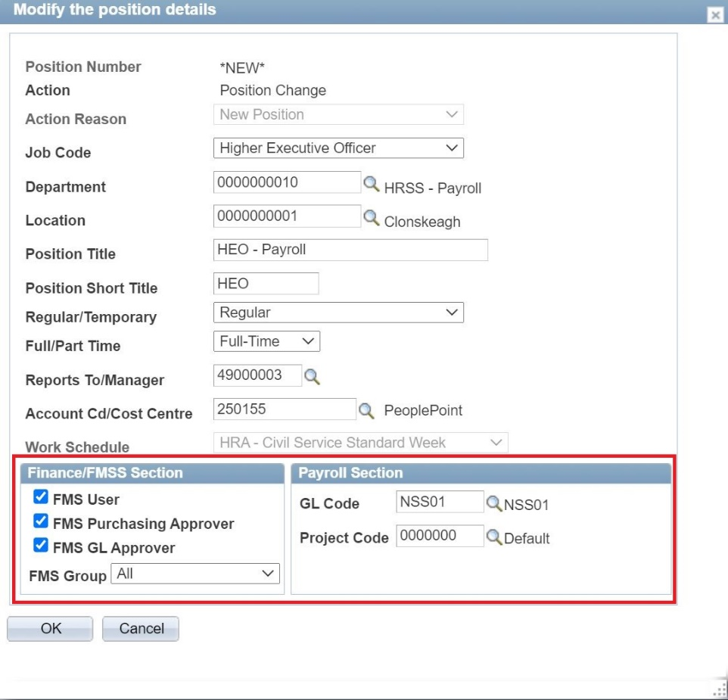

- When assigning a new/vacant position number in a Hire/Internal Transfer, the bottom section of the pop-up box is now dedicated to altering the FMS/Financial Data.

- If the ‘FMS User’ box is ticked, then the ‘FMS Group’ dropdown box become mandatory and a value must be selected.

- The ‘FMS Purchasing Approver’ and ‘FMS GL Approver’ tick boxes remain optional.

- The ‘GL Code’ and ‘Project Code’ fields are mandatory. There must be a value present in these fields for the MIR to be submitted.

- Please be careful when selecting a vacant position as it may have FMS/Financial Data from its previous use. It is important that the fields are reviewed and the appropriate modifications are made.

- If FMS User information is not known at the time of MIR completion, please use the Position Change MIR to provide the officer with FMS User access

  - This must only be done on or after the Hire/Internal Transfer effective date.

