National Shared Services Office

Local HR Leave Management Guide

Local HR Responsibility in the Non - Annual Leave Process
The objective of this ‘How To Guide’ is to outline Local HR’s role in relation to Non-Annual Leave.

The following are types of Non - Annual Leave require final sanction from Local HR:
- Accompany a Spouse Abroad
- Appointment with an International/EU Organisation
- Career Break
- Civil Defence Leave
- Charitable Organisation, Social and Culture Organisation
- Family Illness Leave
- Force Majeure**
- Represent Ireland in a Sport
- Emergency Services Leave
- Study/Exam Leave**
- Unpaid Special Leave

*All other types of Non - Annual Leave are approved by the Employee’s Manager and Local HR will not be involved in these processes

**Applications for 1 day of Force Majeure is approved by the line manager, applications in excess of 1 day require approval from Local HR.
*** Study/Exam Leave is approved by the Employee’s Manager once the NSSO Leave Management team have received a Refund of Fees List from the Department. If an application is received from an Employee who does not appear on the list, the NSSO will contact Local HR for approval.

Please Note: the NSSO may contact Local HR if clarification is needed regarding an Employee’s leave application. This will occur on a case by case basis.

Delegation of Approvals Processes:
If HR for an individual department wish to grant blanket approval for certain leave types they may do so at their discretion. If blanket approval is granted by HR for certain leave types or certain types of applications, the Leave Management team will cease forwarding these applications to the HR mailbox for approval and will instead process the application with only manager approval.

If you wish to grant blanket HR approval for any of the above HR Approved leave types, issue an email to LeaveManagement@nsso.gov.ie with the details of the leave type which you wish to delegate the approval process for and we will process applications for that leave type with only manager approval for your department.

Non-Annual Leave Process:
- For all Non-Annual Leave requests that require the approval of Local HR, employees will submit the request using Employee Self-Service and the employee’s manager will provide a recommendation regarding the employee’s request.

- HR Services’ Leave Management team will then notify Local HR by email of the Non-Annual Leave request awaiting Local HR approval. Local HR should be advised that they can approve / deny the request even if the employee’s manager has recommended otherwise.

- Please note that HRS will adhere to the minimum lead in times for each Non-Annual Leave type as set out by the relevant Circulars. Employees may also be denied Non-Annual Leave if they fail to meet the specific eligibility criteria for the specific leave type as set out by the relevant circulars.

- Once the instruction is received from Local HR to confirm approval of leave, HRS will put in place the next steps i.e. instruct payroll, amend annual leave if applicable.

Non - Annual Leave Process Steps
The diagram below details the NSSO Non - Annual Leave Process.

Local HR’s role in the NSSO Non - Annual Leave process is identified in the one step highlighted in green below. Please see the following pages for full details.
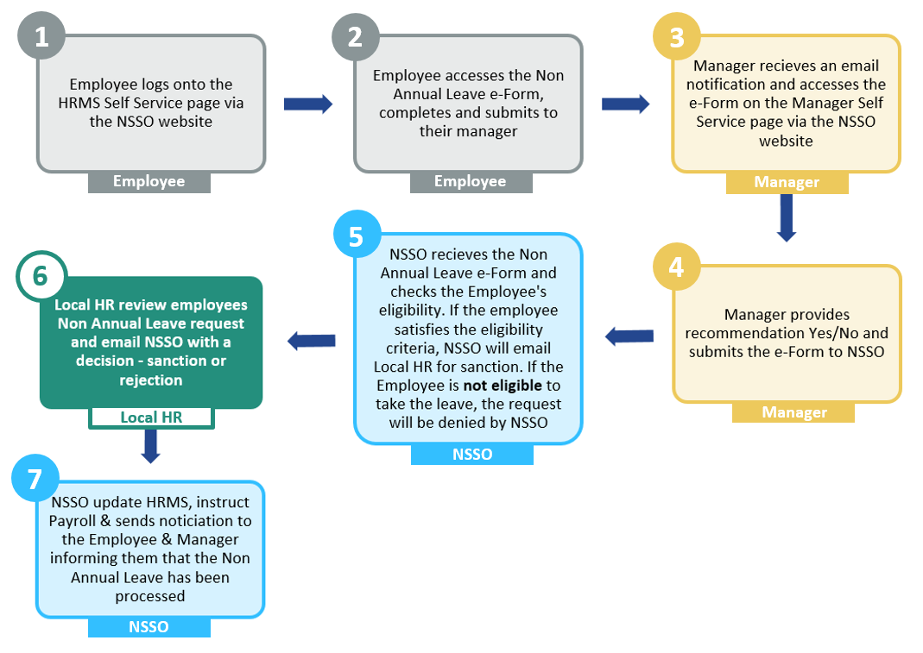

Actions to be completed by Local HR in the NSSO Non - Annual Leave and Worksharing Process

In the NSSO Non - Annual Leave Process, Local HR is responsible for completing the one step in the process. Local HR will also be responsible for completing this step when the NSSO request a decision on a Worksharing change request application. This step is detailed below:

 | Step 6 | Local HR reviews the Employee’s Non -Annual Leave request
1. Local HR receives an email from the NSSO to review an Employee’ s Non-Annual
application

2. Local HR accesses the NSSO Self-service system and views the Employee’s application

3. Local HR reviews a Non - Annual Leave Application

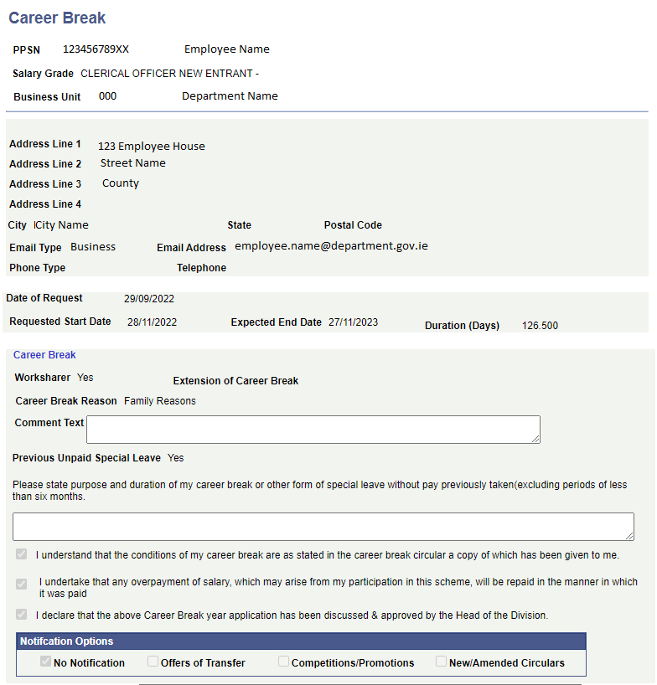
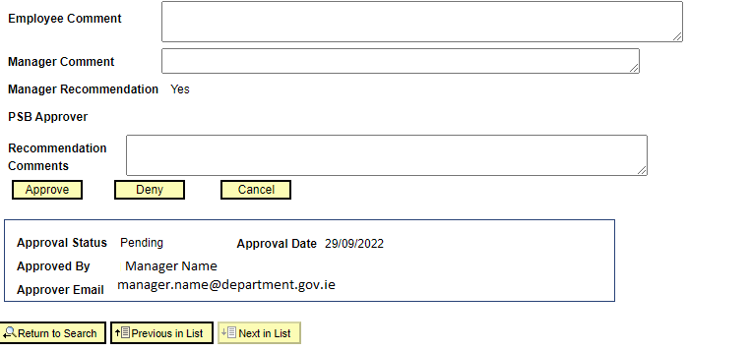

Step 6 | Local HR emails the NSSO with a decision /sanction or rejection
- Local HR sends a final sanction decision to the NSSO

2. Local HR will be included in the final email sent to the Employee
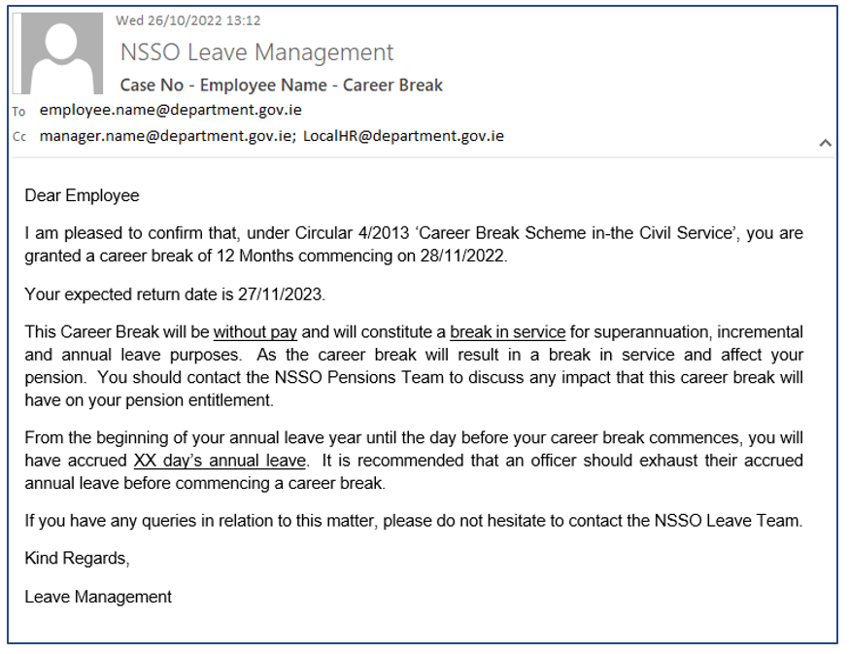

Please Note: If information on the Non - Annual Leave e-form or details regarding the case need to be brought to the attention of Local HR, these will be included in the NSSO email sent to Local HR requesting approval/denial of a Non-Annual leave request.

Please Note: Local HR will be required to confirm sanction or denial of all Workshare requests from eligible staff in their Department/Office. Requests for Worksharing will follow the same process as the Non-Annual Leave process above.

Leave types with Benefit forms:
- For non-annual leave types that require the completion of a benefit form on behalf of an employee (such as Maternity Leave, Carer’s Leave, Paternity Leave and Adoptive Leave), these benefit forms will be completed on behalf of the employee and HR by the HRS Leave Management team.

- For Maternity Leave and Adoptive Leave, the HRS Leave Management team will complete the Employers Section of the Benefit form with the details of the leave and the Department Details and bank information for payment of the benefit to be issued to the employer. This form will then be forwarded directly to the Department of Social Protection on behalf of the employee.

- For Paternity Leave, the HRS Leave Management team will complete the PB2 with the details of the leave and the Department details and bank information for the payment of the benefit to be issued to the employer. This form will then be posted/emailed to the officer for them to submit the form as part of their online application for Paternity Benefit.

- For Carer’s Leave the HRS Leave Management Team will complete the CARB1 with the Carer’s Leave and work details of the officer and will forward the form to the Carer’s Benefit section of DSP on behalf of the officer (unless the officer specifically requests that the form be returned to them)

Refund of Fees Lists:
- Departments should retain a list of officers who have been approved for a refund of academic fees applied for under Circular 23/2007

- As of 2020, the HRMS has been updated to automate the processing of Study Leave applications where an officer is registered on the system as being approved for a refund of fees

- In order to ensure that these applications can be processed for officers applying for Study Leave, it is important that HR Departments forward a copy of the Refund of Fees list for their department to LeaveManagement@nsso.gov.ie at the start of each academic year.

- If a Refund of Fees list is not received for a department, each application for Study Leave or Exam Leave will be issued to HR for approval.

- Where a Refund of Fees list has been received for a department HR will not be contacted to confirm approval for paid Study or Exam Leave for any officer who is on the list.

- For applications for Unpaid Study or Exam Leave for any officer or applications for Paid Study or Exam Leave for officers not on the ROF list, HR approval will be sought prior to the applications being processed

- A template copy of the refund of fees template list is issued annually with an alert, but can be requested at any point from the NSSO Leave Management team.
  - The following fields must be completed in order for the list to be accepted by the HRMS upload system:
    - Name
    - PPSN
    - Qualification Level
    - Duration of Course (in years)
    - Year of study
    - Study Leave entitlement
  - The study leave entitlement will auto-calculate to 3 days for any course that is Level 5 or lower, to 5 days for any Level 6 course or the first years of any course that is Level 7 or to 10 days for the final year of a Level 7 or higher qualification

This entitlement can be manually amended by HR staff for worksharing officers who may be entitled to a pro-rata entitlement, or where a different entitlement is applicable. The password to amend the study leave entitlement is noted at the top of the ROF template

