Submit a HR Case
You have the same username and password for the NSSO HR self-service (HRMS), Case Management System (CMS), Performance Management and Development System (ePMDS), and Probation system (eProbation), as well as for OneLearning. The password for all of these systems can only be set or changed on your HR self-service account.

Logging in to the Case Management System (CMS)
Step 1: Go to www.nsso.gov.ie and select ‘Submit a HR Case’
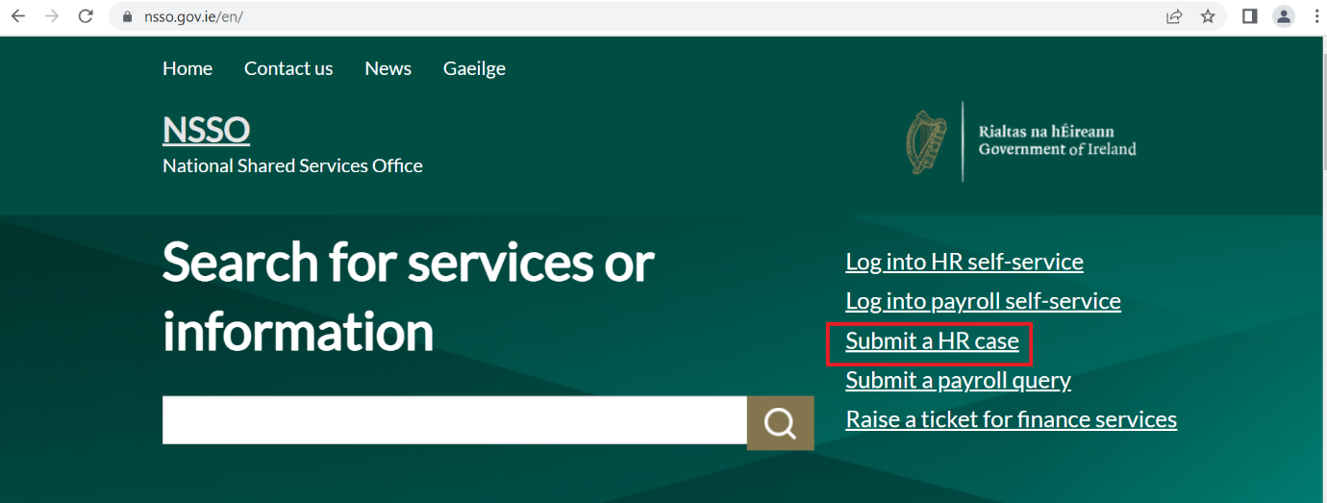

Step 2: Log in to the Case Management System (CMS) using your username and password.
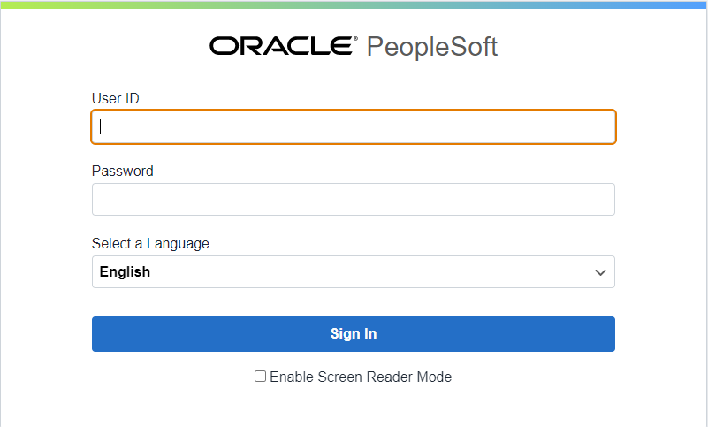

Raise a case
Step 1: Create a New Case using either ‘Create New Case’ or ‘Add Case’ link
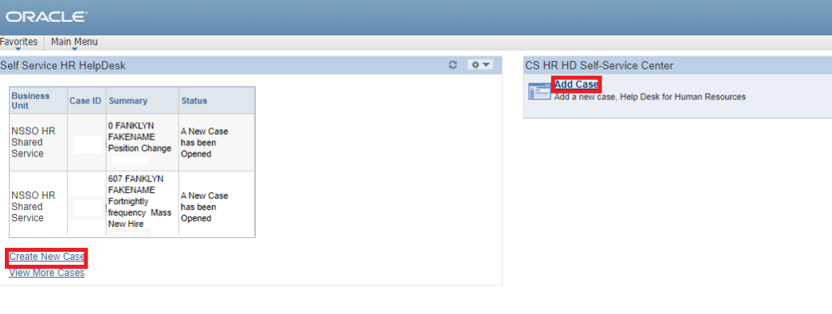

Step 2: Enter the appropriate information relating to your case.
- Category – the NSSO team / area involved
- Requirement - choose the most relevant option
- Case Detail (if appropriate)
- Give a brief case summary
- Provide case details
- Attach file (if appropriate)
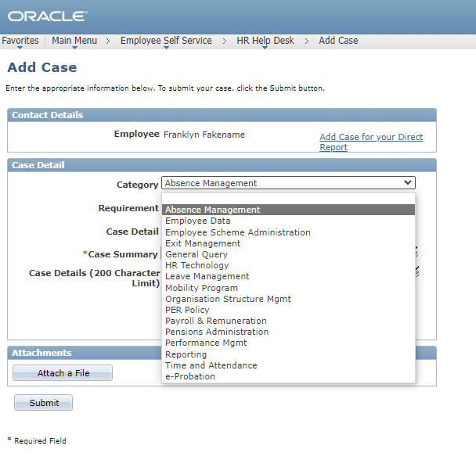
A few moments after pressing ‘Submit’, you will receive an automated email with a case ID, acknowledging a case has been raised on your profile.
Raise a case for a direct report
Repeat steps 1 and 2 from ‘Logging in to the Case Management System (CMS).

Step 1: Create a new case using either ‘Create New Case’ or ‘Add Case’ link.
Step 2: Click ‘Add Case for your Direct Report’
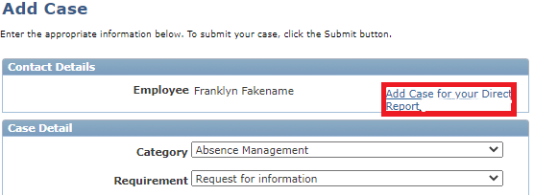

Step 3: Choose your direct report from the list of direct reports
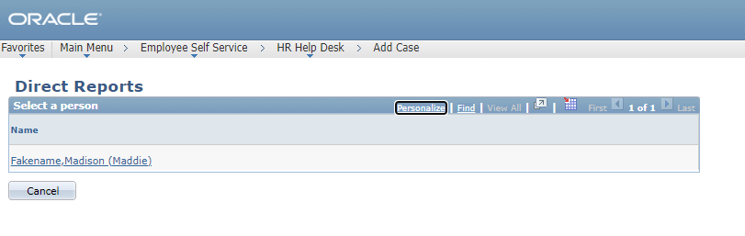

Step 4: Enter the appropriate information relating to your direct reports case.
- Category
- Requirement
- Case Detail (if appropriate)
- Give a brief case summary
- Provide case details
- Attach file (if appropriate)
- Submit

Manage your HR Case
To manage a case you have already raised, click the ‘Manage Cases’ button.
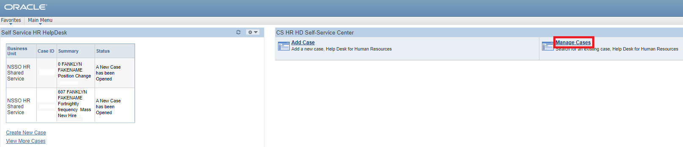

Choose from an option on the ‘*Predefined Search’ drop down list.
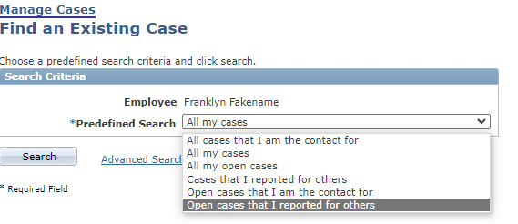
After choosing your case, you can check the case information, case history, or add a note or attachment to the case.

Note: If you add a comment or an attachment to a case after it was raised, the relevant NSSO team is not notified. If your case or additional information is urgent you should email the relevant team instead, or call the NSSO on 0818 107 100 choosing option 2 for HR Services.

