Guide to
“What If I Take” calculator
Contents
“What If I Take” calculator 3
Log into the Payroll Self-Service 3
Parental Leave Calculator 5
Worksharing Calculator 9
Shorter Working Year (SWY) Pro Rata Calculator 14
Carer’s Leave 18

“What If I Take” calculator

The “What If I Take” calculator is a facility on Payroll Self-Service where you can calculate an estimate of your salary if you wish to apply for parental leave, workshare and shorter working year (pro rata). The facility will output an estimated net pay figure based on your current gross pay, allowances, deductions and the criteria you select. This calculator is offered for estimation purposes only.
The amount calculated by the calculator is an indication only, it is not a guarantee that you will receive that amount. Any changes between when you use the calculator to when the unpaid leave is taken can affect the payment.
The facility will produce an estimated net pay figure based on your most recent payslip.
It is important that this facility is used during a standard pay period where you are not in receipt of any additional payments, for example, increment, arrears or overtime. This will ensure that the estimate is more reflective of your normal pay.
All applications should be processed in line with your HR guidelines.

Log into the Payroll Self-Service
The Payroll Self-Service can be accessed through our website www.nsso.gov.ie
Navigate to the Log into payroll self-service
Select access payroll self-service
Select your department/office from the list displayed
When prompted enter registered email address and password
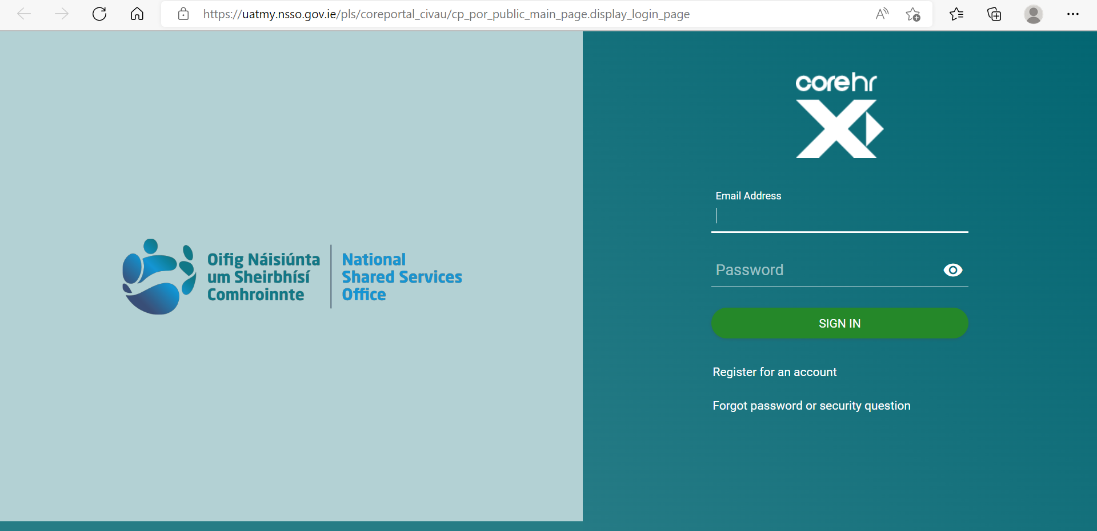

Complete your registered Security Question
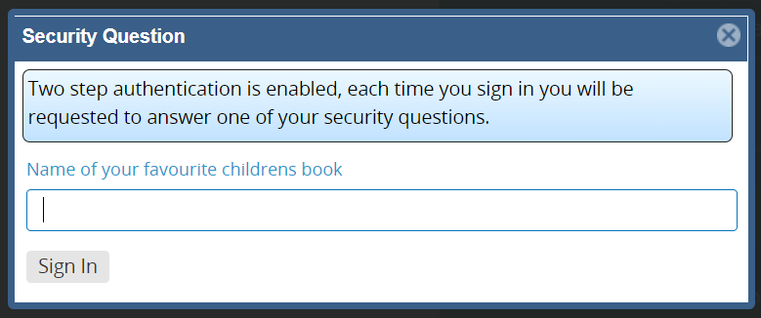
Please note: If asked a security questions you did not set up, you are working from a shortcut or an expired link, we recommend to always access the payroll self-service through our website.
Once logged into the payroll self-service ensure you are working from the employee dashboard
Please select the last icon listed along the menu bar on the left of the screen
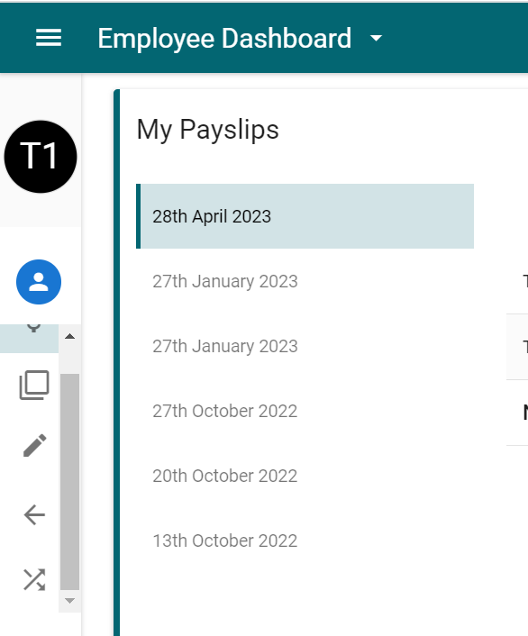
The following calculator options are available for selection:
- Parental Leave
- Workshare
- Shorter Working Year (Pro Rata)
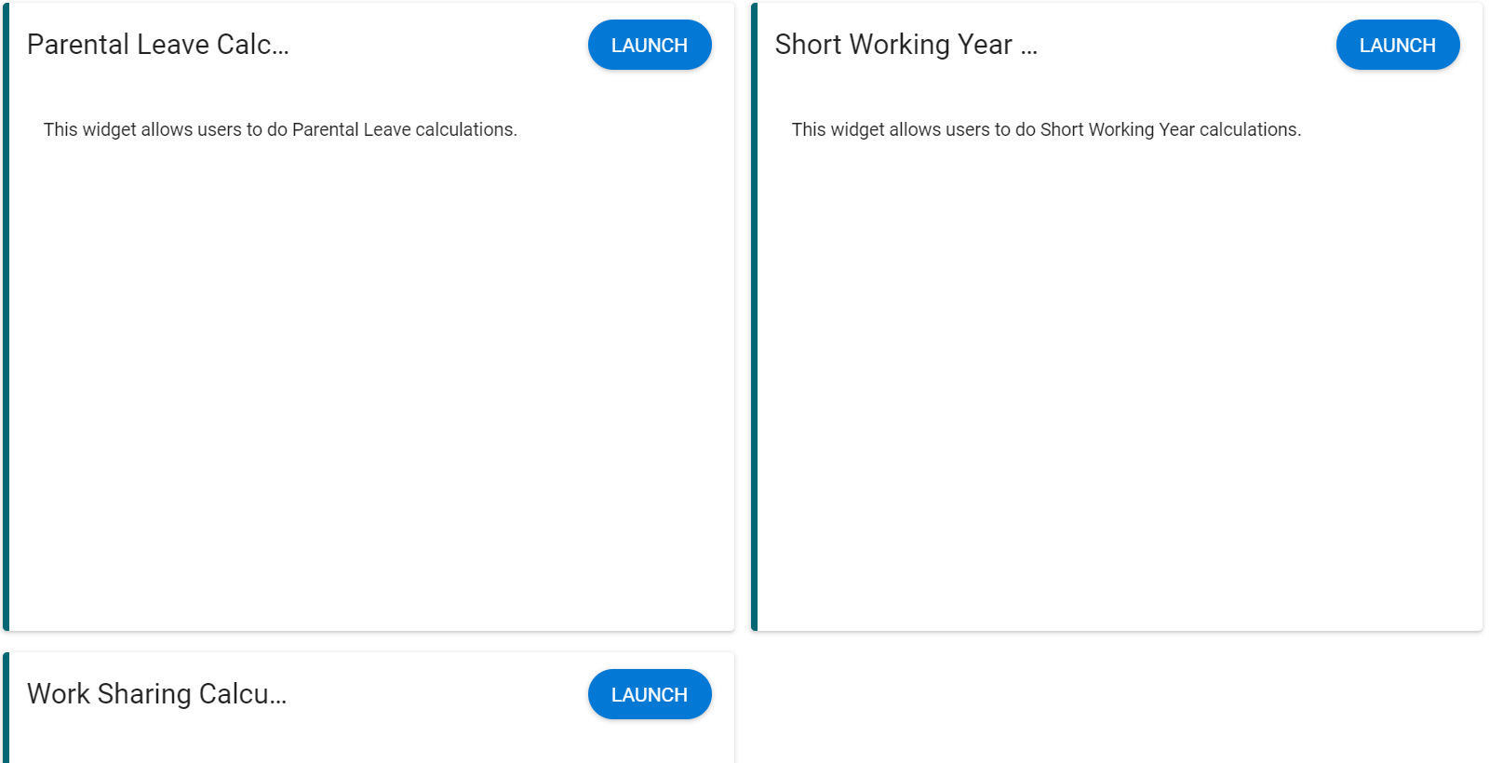

Parental Leave Calculator
Please see Circular 22-1998 and 22-2000 for more information on Parental leave, we recommend reading this before estimating and applying.

Weekly example:
Navigate to the Parental Leave Calculator
On the right hand side of the calculator click on the Launch Button
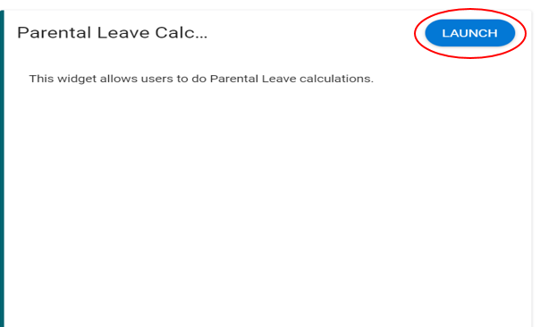

The page that is displayed will outline what the calculator can do and allow you to select the number of parental leave days you wish to calculate.
A disclaimer is also displayed which will need to be read and agreed to in order to proceed.
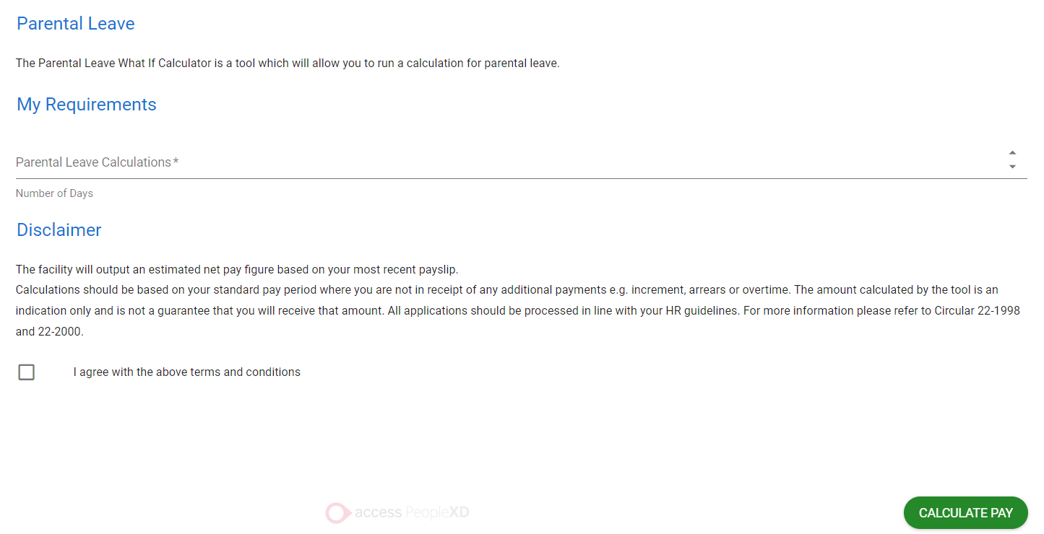

When prompted input the number of day(s) per week being taken.
When you have read the disclaimer tick to agree to the terms and conditions
Navigate to the bottom right hand side of the screen and select calculate Pay
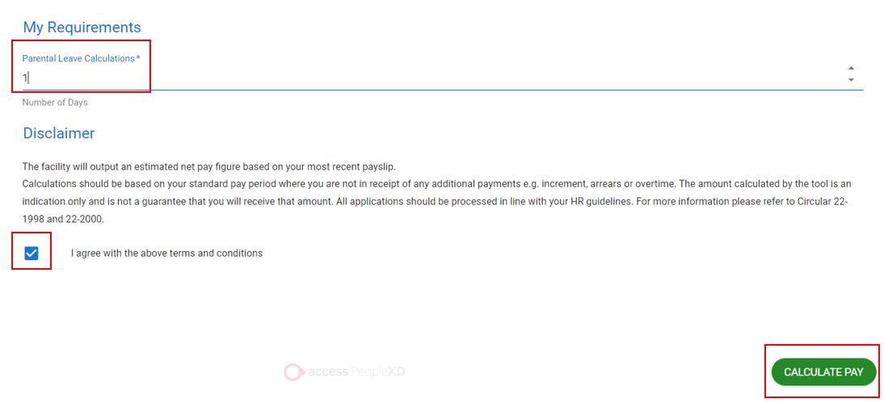

Calculations below are based on salary for weekly paid employee taking one day Parental Leave. Calculation is based on 5 days.
Gross Salary divided by 5 and mutiplied by 4 or 80%
€672.46/5 X 4 = €537.97
Or
€672.46 X .8 = €537.97
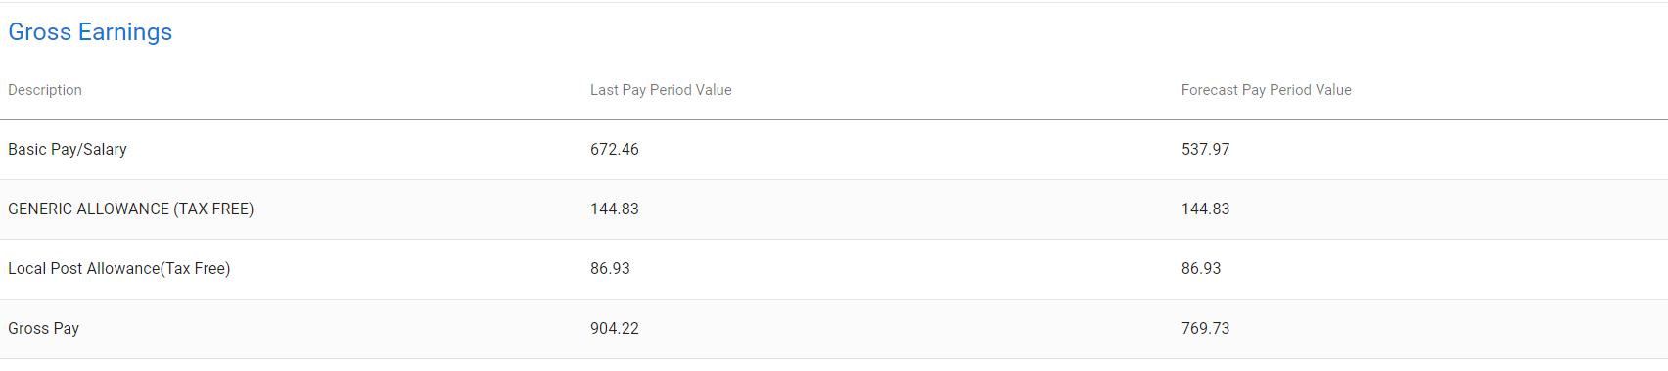

Statutory and voluntary deductions are recalculated to reflect reduction in salary.
The first column is last pay period value and immediately to the right of this will be the estimated figure associated with the entries and this is called the forecast pay period value.

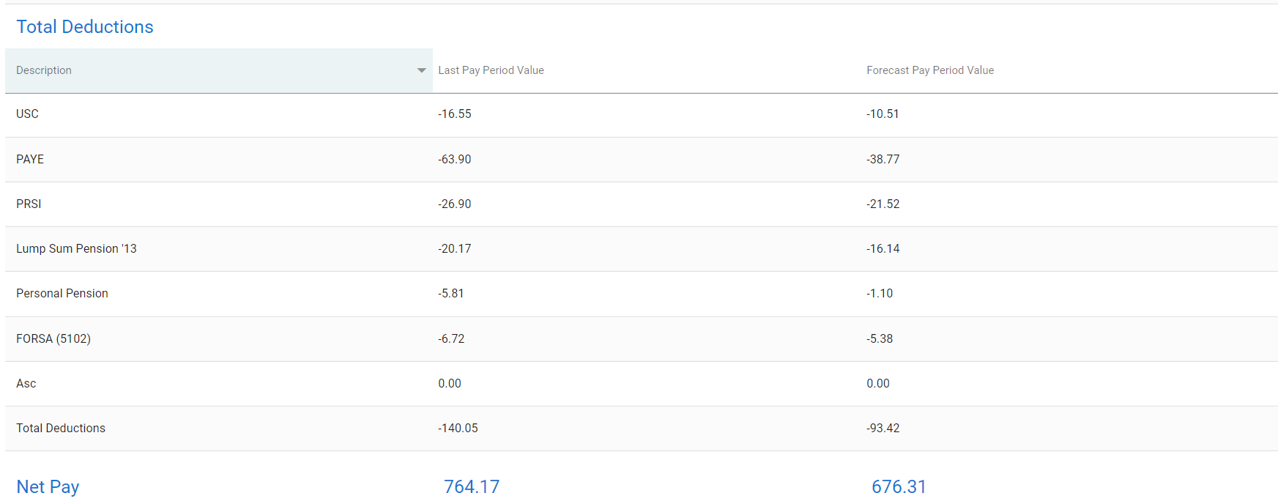

Fortnightly example:
Navigate to the Parental Leave Calculator
On the right hand side of the calculator click on the Launch Button
When prompted input the number of day(s) per fortnight being taken.
When you have read the disclaimer tick to agree to the terms and conditions
Navigate to the bottom right hand side of the screen and select calculate Pay

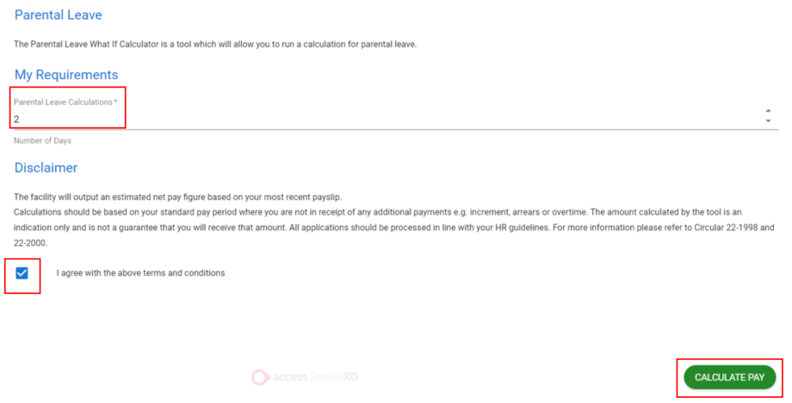

Calculations below are based on salary for Fortnightly paid employee taking 2 days Parental Leave per fortnight.
Calculation is based on 10 days.
Gross Salary divided by 10 and mutiplied by 8 or 80%
€1,668.11 /10 X 8 = €1,344.49
or
€1,668.11 X .8 = €1,344.49

Statutory and voluntary deductions are recalculated to reflect reduction in salary.
The first column is last pay period value and immediately to the right of this will be the estimated figure associated with the entries and this is called the forecast pay period value.

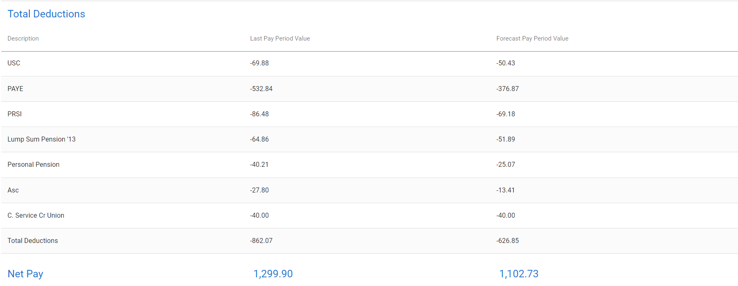

Worksharing Calculator

Please see Circular 31-2001 for more information on worksharing, we recommend reading this before estimating and applying.

Weekly example:
Navigate to the Worksharing Calculator
On the right hand side of the calculator click on the Launch Button

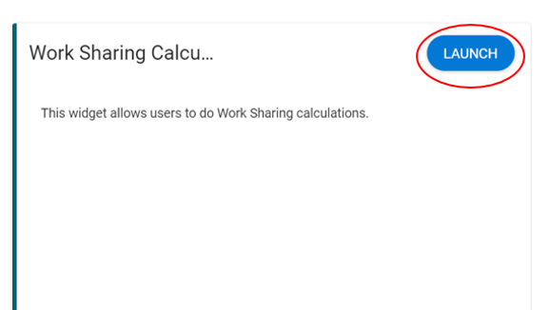
Under the “My Requirements” section you will be able to select from a dropdown the worksharing option that you want calculated.
When you have read the disclaimer tick to agree to the terms and conditions
Navigate to the bottom right hand side of the screen and select calculate Pay
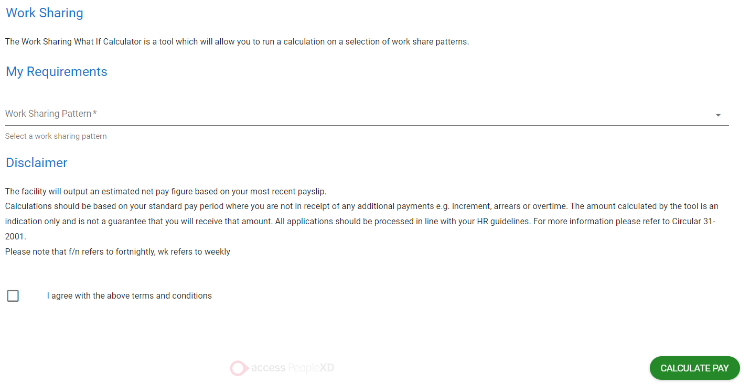

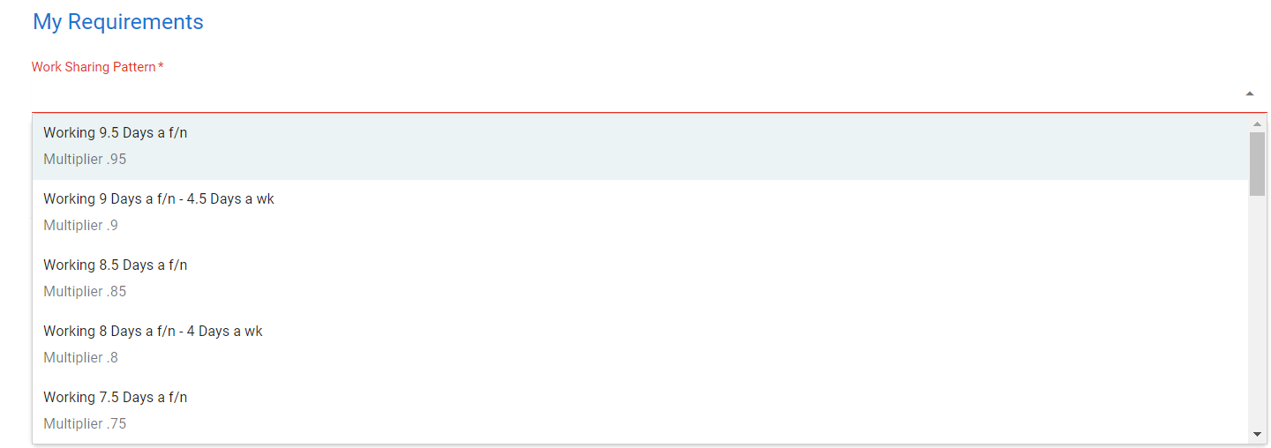

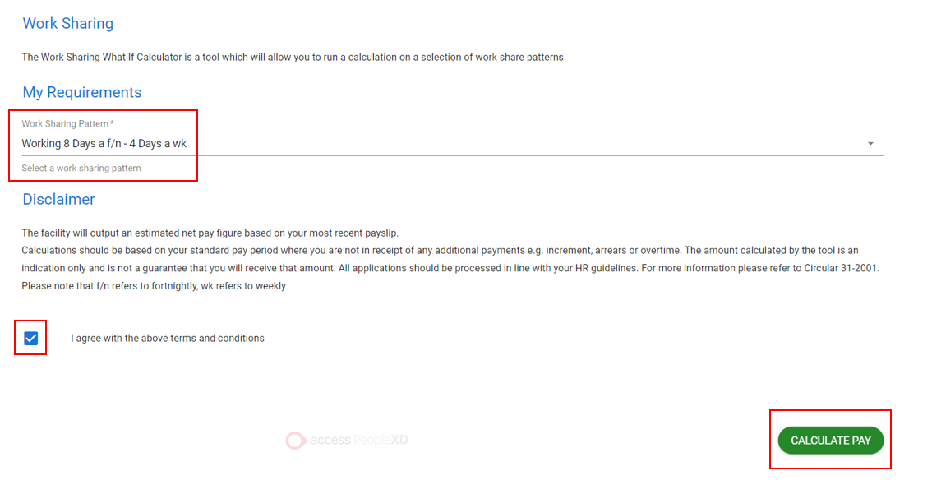

Weekly example:
Calculations below are based on salary for weekly paid employee increasing their workshare pattern from 50% to 80%.
Calculation is based on 5 days.
Gross Salary divided by 5 and mutiplied by 4 or 80%. Higher Duty Allowance calculation is based on employee’s pay multiplier.
Salary at 100% is €612.75
€612.75/5 X 4 = €490.18
or
€612.75X .8 = €490.18

Statutory and voluntary deductions are recalculated to reflect reduction in salary.
The first column is last pay period value and immediately to the right of this will be the estimated figure associated with the entries and this is called the forecast pay period value.

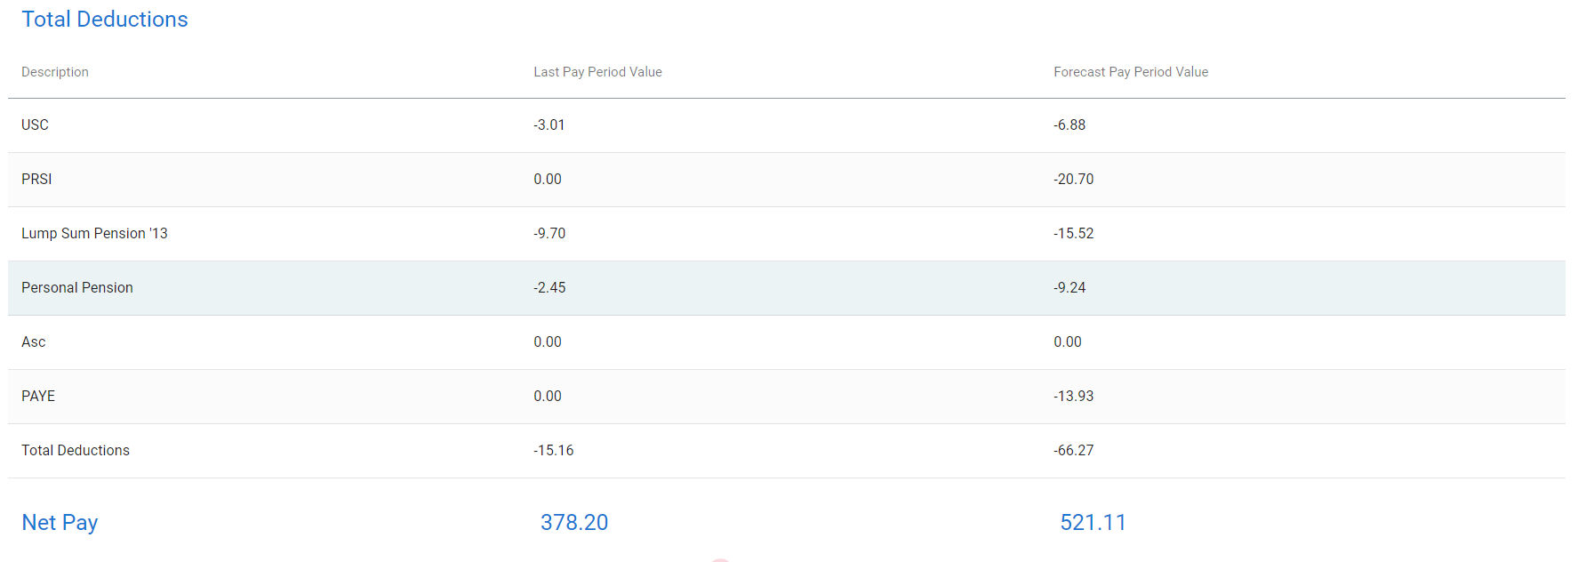

Fortnightly example:
Under the “My Requirements” section you will be able to select from a dropdown the worksharing option that you want calculated.
When you have read the disclaimer tick to agree to the terms and conditions
Navigate to the bottom right hand side of the screen and select calculate Pay

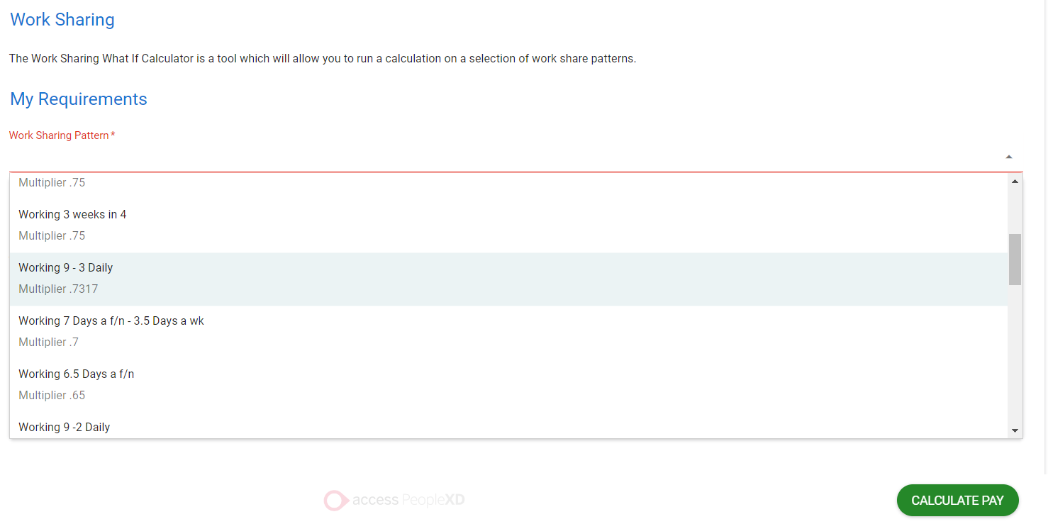
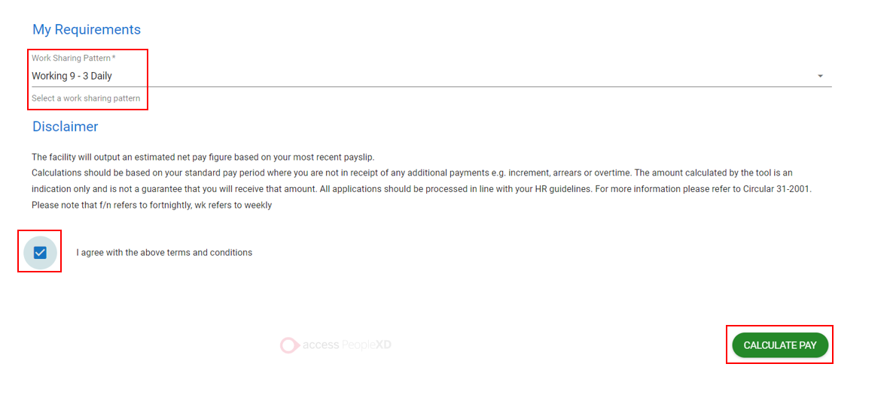

Calculations below are based on salary for fortnightly paid employee going from 100% salary to 9-3 worksharing pattern (73.17%), working 9-3 daily.
Gross Salary mutiplied by .7317 or 73.17%
€1,668.11 X .7317 = €1,220.56
or
€1,668.11 X 73.17% = €1,220.56

Statutory and voluntary deductions are recalculated to reflect reduction in salary.
The first column is last pay period value and immediately to the right of this will be the estimated figure associated with the entries and this is called the forecast pay period value.

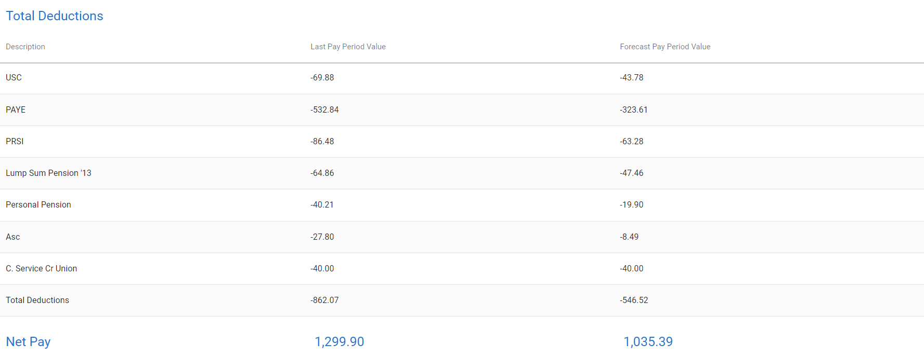

Shorter Working Year (SWY) Pro Rata Calculator

Please see Circular 14-2009 and our guide on Shorter working year pro rata https://nsso.gov.ie/en/publications/shorter-working-year-pro-rata-calculation/ for more information. We recommend reading these before estimating and applying.
Please note that if you are intending on taking SWY please ensure to keep your first payment of the year in which you are taking SWY pro rata as regular as possible full information is contained in the aforementioned guide.

Shorter Working Year pro rata Calculations are normally based on the first pay period of the year in which the SWY absence is being availed of, however, the What If I Take calculator uses the last pay period’s net pay figure to provide the estimated shorter working year deduction.
Weekly example:
Navigate to the Shorter Working Year Pro-Rata Calculator
On the right hand side of the calculator click on the Launch Button

Click on the Launch Button
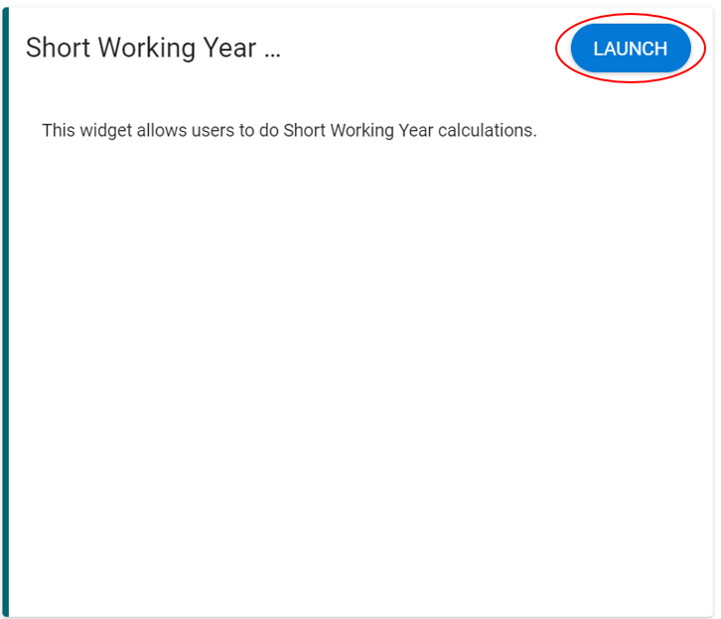
Under the “My Requirements” section you will be able to select from a dropdown the dates associated with the periods of SWY you want calculated.
There are a maximum of three leave periods to use.
Each period of leave should commence on a Monday (regardless of your working pattern)
Under the section called “Periods” enter the number of weeks for the Leave Period in question.
When you have read the disclaimer tick to agree to the terms and conditions
Navigate to the bottom right hand side of the screen and select calculate Pay
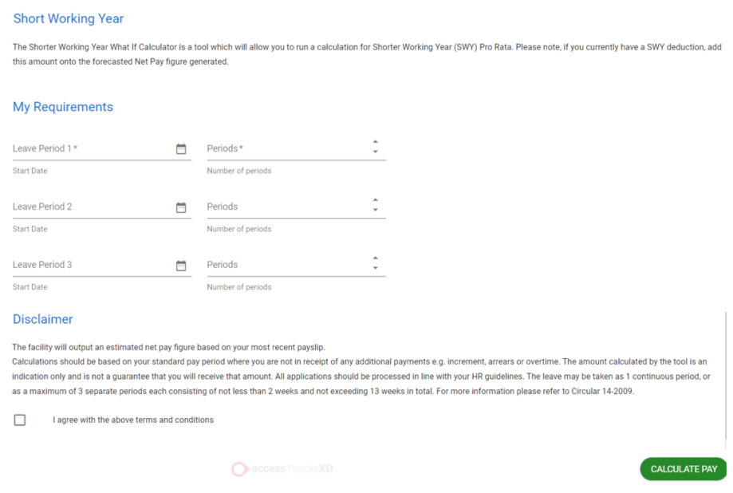

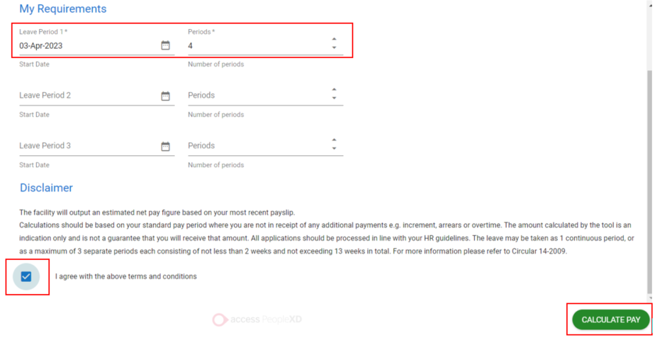

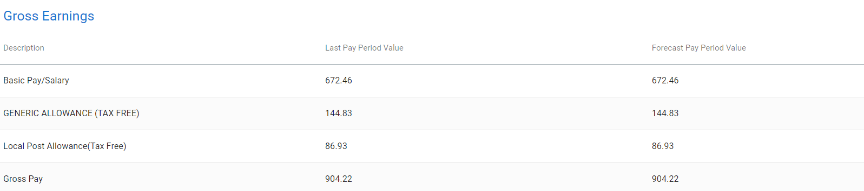

Weekly example:
The Shorter Working Year Pro - Rata calculation is based on a weekly paid employee, divided by the number of weeks in the year, multiplied by the number of weeks you wish to take.
This will become your SWY deduction. SWY net pay deduction displays under total deductions.
In this case the calculation is based on weekly paid employee taking 4 weeks SWY – Last pay period’s net pay €764.17/52 X 4 = €58.78 is the SWY deduction.
The deduction value multiplied by the number of weeks worked, divided by the number of weeks on SWY will be your SWY allowance.
In this case, the deduction taken over 48 weeks and paid out for duration SWY leave.
Deduction of €58.78 X 48 weeks = €2,821.44/4 weeks = €705.36 weekly SWY allowance.

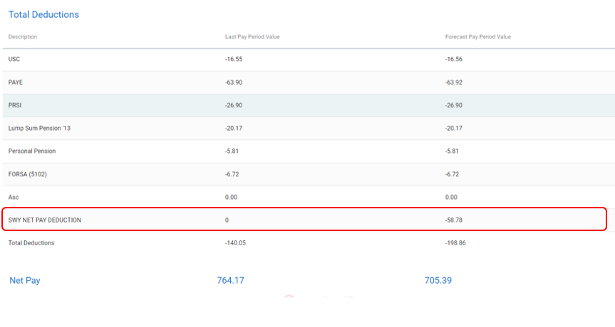

Fortnightly example:
Input leave period date and number of periods (Each period date should commence on a Monday)
Tick agree to terms and Conditions
Select calculate
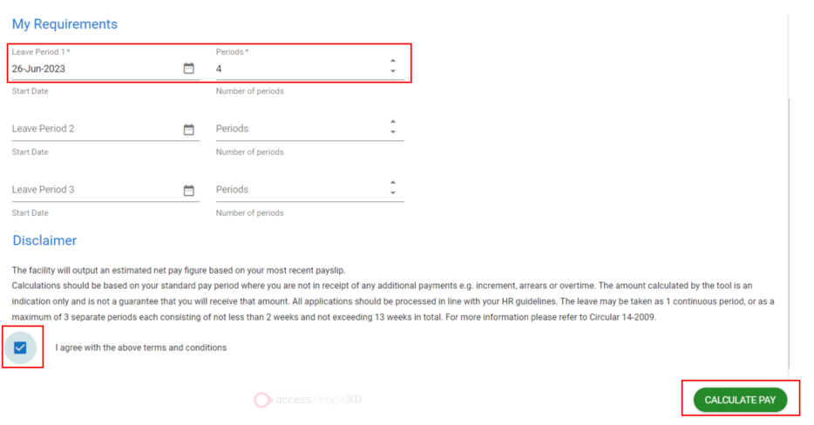

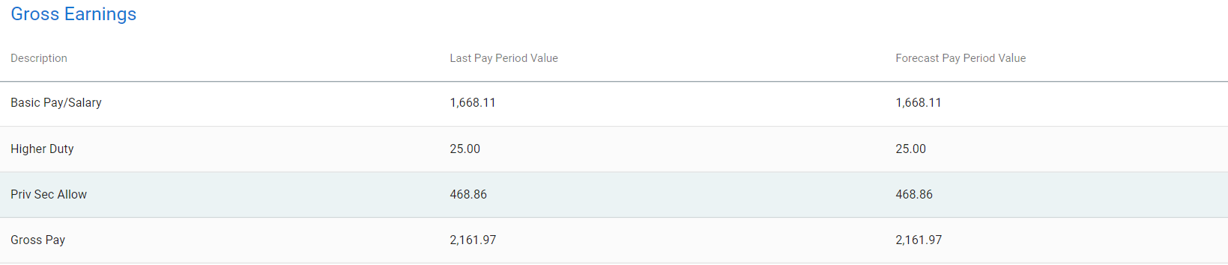
Fortnightly example:
The shorter working year calculation is based on a fortnightly paid employee, divided by the number of fortnights in the year, multiplied by the number of fortnights you wish to take.
This will become your SWY deduction. SWY net pay deduction displays under total deductions.

In this case the calculation is based on fortnightly paid employee taking 4 fortnights SWY – Last pay period’s net pay €1,299.90/26 X 4 = €199.98

The deduction value multiplied by the number of fortnights worked divided by the number of fortnights on SWY will be your SWY allowance.
Deduction taken over 22 fortnights and paid out for duration SWY leave.
Deduction of €199.98 X 22 fortnights = €4,399.56/4 fortnights = €1,099.89 fortnightly SWY allowance.

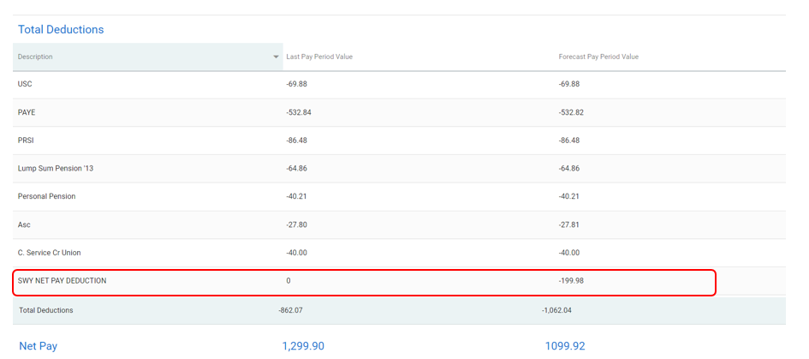

Carer’s Leave

Please see Carer’s Leave Act, 2001 for more information, we recommend reading this before estimating or applying.
As per the Carer’s Leave Act 2001, the maximum number of hours that an employee can work is 18.5 hours per week.
In order to facilitate estimates the weekly multiplier of 0.4485 and the fortnightly multiplier of 0.4485 is available to select under the Worksharing Calculator. Please follow the directions under the Worksharing section for this estimate.
Please note this is an estimate and employees must refer to the Act for further information on legislative criteria.

